

# Database Management System Project Topic: Railway Reservation System Subject code: CS593

**Group no. - 05**

**Names: Prithviraj Bhowmick(09) Saptarshi Bose(10)**

**Section:CSE3D**

**Subject: Database Management Systems Laboratory**

**Enrolment no. :**

**Batch: 2017-2021**

**University of Engineering and Management(Kolkata)**

### INDEX:

#### Acknowledgement………………………………………… 3 Introduction to topic ……………………………………... 4 ER Diagram ………………………………………………. 5 Sample SQL queries ……………………………………… 6 Useful queries related to the database ………………….. 14 Relational model …………………………………………. 23 Future scope of project…………………………………… 24 Conclusion ………………………………………………… 25

**Remarks ………………………………………………….. 26**

**Acknowledgement**

We, Prithviraj Bhowmick and Saptarshi Bose from CSE3D, would firstly like to thank our University for providing us with the infrastructure we used to learn about the subject. Secondly, we would thank Sukalyan Goswami sir, HOD of Computer Science Engineering department, UEM Kolkata. Thirdly we would love to thank our concerned subject teachers Varsha Poddar and Subarna Sen for providing us with the project idea and necessary study material for the project.

Introduction:

Railway Reservation System:

A railway reservation system is required by a booking platform where railway tickets are booked. It must have all information regarding the trains and the passengers. As for the trains, it must include data regarding the status of the train, the route of the train and also the information about the stations. As for the passengers it should have the details of the passengers and details of the ticket. Passengers should be booked under certain users who have access to the database.

This is one of the most widely used system that requires a powerful database acting in the background. Under a reservation system there are thousands of trains which are boarded by millions of passengers. If not stored under a database through a properly programmed GUI, keeping track of trains and passengers is quite impossible. Thus, a database is strongly required in order to add, manipulate and delete passenger and train details effectively and efficiently.

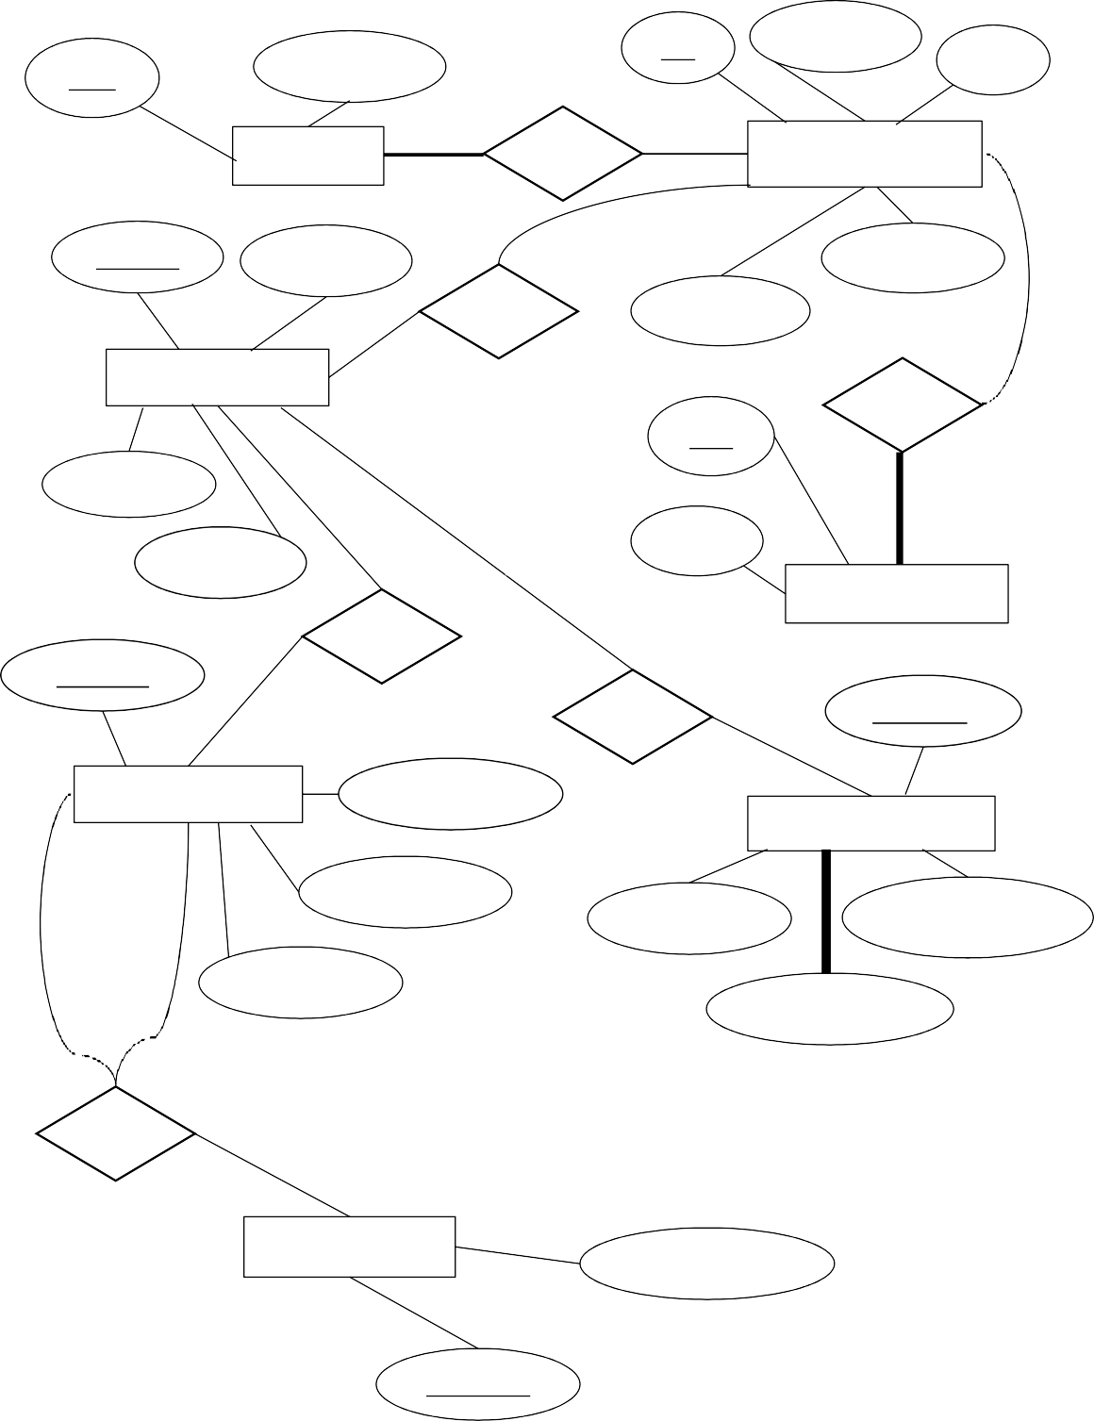

**ER- Diagram:**

Pnr

P_name

U_id

Password

Age

User

1

N

Has

Passenger

N

Train_id

T_name

Seat no.

Has

Gender

1

Train

1

Has

T_id

Dept_d

1

Arr_d

1

1

Price

Ticket

Has

Route_id

1

Has

Status_id

1

Route

No_of_stop

Status

Start

Dept_time

Wait_seat

Booked_seat

Arr_time

Avail_seat

End

Has

Station

Station_name

Station_id

**Sample SQL queries:**

Creations:

#### Users

create table users( user_id varchar2(20) primary key, password varchar2(20) not null

);

alter table users add constraint chk1 check (lengthb(password)>=8);

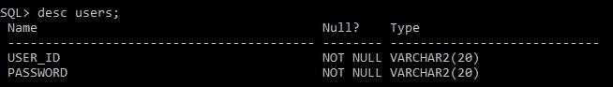

### Passenger

create table passenger( pnr varchar(8) primary key, p_name varchar2(30),

age number, gender varchar(10), seat_no number,

reserve_stat varchar2(10),

u_id varchar2(20) not null references users(user_id), status_id varchar2(10) not null,

train_id varchar2(10) not null);

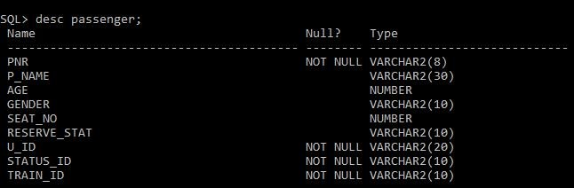

### Train Status

create table train_stat( tstatus_id varchar2(10) primary key, wait_seat number,

avail_seat number, booked_seat number,

train_id varchar2(10) not null);

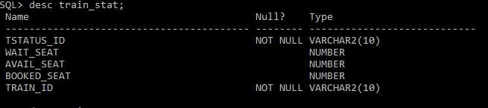

### Train

create table train( train_id varchar2(10) primary key, t_name varchar2(20) not null,

car_no number,

status_id varchar2(10) not null references train_stat(tstatus_id));

alter table train_stat add constraint train_fk foreign key(train_id) references train(train_id);

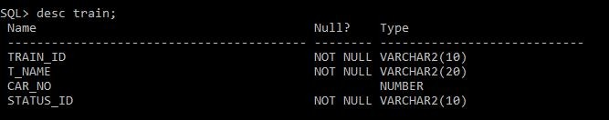

### Station

create table station( station_id varchar2(10) primary key, station_name varchar2(30));

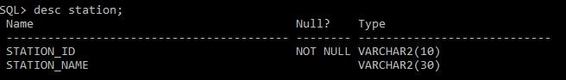

### Route

create table route( route_id varchar2(10) primary key,

from_st varchar2(10) references station(station_id), to_st varchar2(10) references station(station_id), arr_time varchar2(5),

depart_time varchar2(5), no_of_stops number,

train_id varchar2(10) references train(train_id));

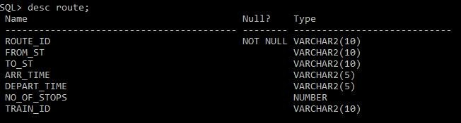

Alterations:

1. SQL>alter table train drop column status_id; ( had conflicting foreign key)

SQL>alter table train add dept_date date; SQL> alter table train add arr_date date;

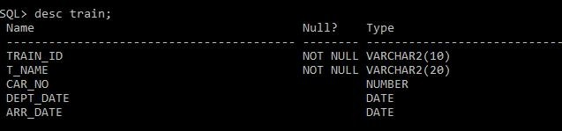

1. SQL> alter table passenger add constraint cst2 foreign key(train_id) references train(train_id);

SQL> alter table passenger add compart_no varchar(10);

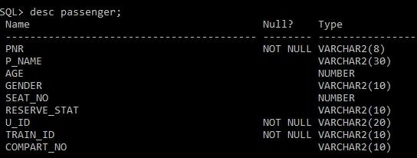

## Insertions:

Table: Users->

insert into users values('145FG','kolkata7'); insert into users values('147L2','prithviraj'); insert into users values('22LO4','dbmsproj');

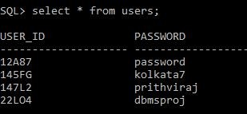

Table: Station->

insert into station values('KOL001', 'Kolkata'); insert into station values('DEL012', 'Delhi'); insert into station values('AGR234', 'Agra');

insert into station values('VSK111', 'Vishakhapatnam'); insert into station values('BOM212', 'Mumbai');

insert into station values('CHH141', 'Chennai'); insert into station values('BAN154', 'Bengaluru');

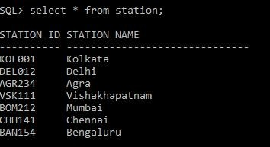

Table: Train->

insert into train values('HWDLJNS10','Janashatabdi',20); insert into train values('AGVKDU11','Duranta',15);

insert into train values('HWBMBE45','Bombay Express',16); insert into train values('CHDLRD14','Rajdhani',20);

insert into train values('HWDLRD10','Rajdhani',20); insert into train values('BMDLRD74','Rajdhani',20); insert into train values('HWDLJNS12','Janashatabdi',20); insert into train values('BMDLRD84','Rajdhani',20);

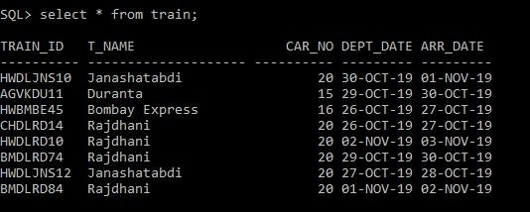

Table: Train_stat->

insert into train_stat values('ST100',0,1000,2000,'HWDLJNS10'); insert into train_stat values('ST101',500,0,2500,'AGVKDU11'); insert into train_stat values('ST102',0,400,2000,'HWBMBE45'); insert into train_stat values('ST103',0,40,2000,'CHDLRD14'); insert into train_stat values('ST104',544,0,2500,'HWDLRD10'); insert into train_stat values('ST105',40,0,2080,'BMDLRD74'); insert into train_stat values('ST106',0,200,2080,'HWDLJNS12'); insert into train_stat values('ST107',40,0,2600,'BMDLRD84');

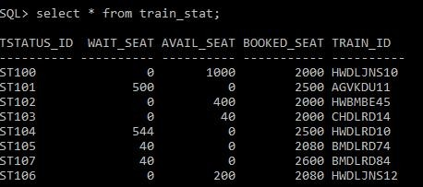

Table: Route->

insert into route values('RT100','KOL001','DEL012','00:45','14:50',26,'HWDLJNS10');

insert into route values('RT101','KOL001','DEL012','17:45','08:15',26,'HWDLJNS12');

insert into route values('RT102','KOL001','DEL012','21:45','06:50',10,'HWDLRD10');

insert into route values('RT103','AGR234','VSK111','17:45','10:15',30,'AGVKDU11');

insert into route values('RT104','KOL001','BOM212','15:10','16:50',33,'HWBMBE45');

insert into route values('RT105','CHH141','DEL012','02:25','21:15',12,'CHDLRD14');

insert into route values('RT106','BOM212','DEL012','17:15','04:50',11,'BMDLRD74');

insert into route values('RT107','BOM212','DEL012','23:45','08:45',10,'BMDLRD84');

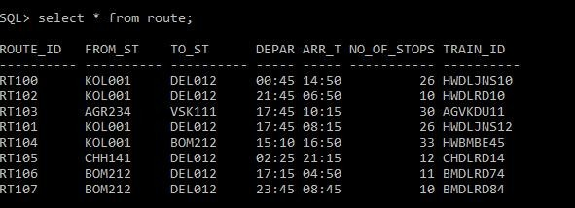

Table: Passenger->

insert into passenger values('ADM101','Prithviraj',20,'Male','140','Booked','145FG','HWDLRD 10');

insert into passenger values('ADM102','Prasad',23,'Male','141','Booked','145FG','HWDLRD10')

;

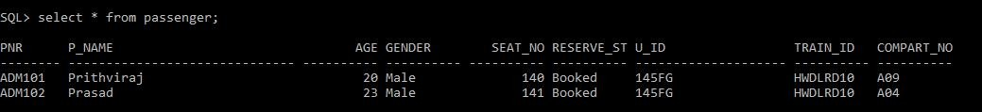

Table: Ticket->

insert into ticket values('T102','ADM102',700); insert into ticket values('T101','ADM101',600);

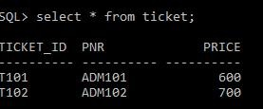

# Useful SQL queries related to the database:

#### Passengers booked by specific user id:

* 1. SQL> select * from passenger where u_id = '145FG';



#### Trains going to Delhi:

* 1. SQL> select train_id,to_st,t_name from route natural join train where to_st = (select station_id from station where station_name = 'Delhi')**;**

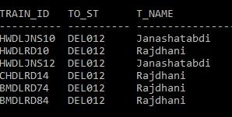

#### Trains starting from Kolkata;

* 1. SQL> select train_id,to_st,t_name from route natural join train where from_st = (select station_id from station where station_name = 'Kolkata');

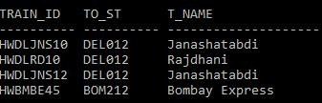

#### Trains starting from Kolkata going to Delhi:

* 1. SQL> select train_id,to_st,t_name from route natural join train where from_st = (select station_id from station where station_name = 'Kolkata') and to_st = (select station_id from station where station_name = 'Delhi');

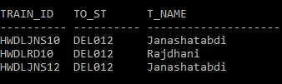

#### Details of passengers going from Kolkata to Delhi:

* 1. SQL> select pnr, p_name, age , gender , train_id from passenger natural join train natural join route where from_st = (select station_id from station where station_name = 'Kolkata') and to_st = (select station_id from station where station_name = 'Delhi');

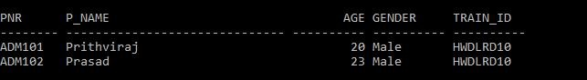

#### Trains having zero vacancy:

* 1. SQL> select train_id,t_name from train natural join train_stat where wait_seat > 0;

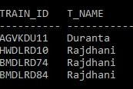

#### Stations connected via train named Rajdhani:

* 1. SQL> select from_st, to_st from route natural join train where t_name

= 'Rajdhani';

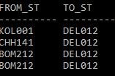

#### status of the trains going from Kolkata:

* 1. SQL> select train_id, wait_seat, avail_seat, booked_seat from route natural join (train natural join train_stat) where from_st = (select station_id from station where station_name = 'Kolkata');

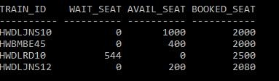

#### Status of trains reaching Delhi:

* 1. SQL> select train_id, wait_seat, avail_seat, booked_seat from route natural join (train natural join train_stat) where to_st = (select station_id from station where station_name = 'Delhi');

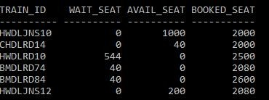

#### No. of train cars in Rajdhanis along with stations :

* 1. SQL> select train_id, t_name, car_no, from_st , to_st from train natural join route where t_name = 'Rajdhani';

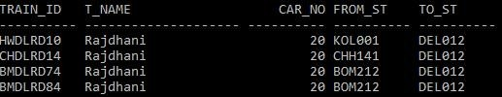

#### No. of stops of trains named Janashatabdi:

* 1. SQL> select train_id, t_name, no_of_stops , from_st , to_st from train natural join route where t_name = 'Janashatabdi';

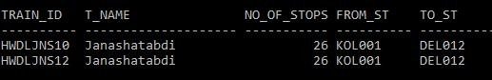

#### No. of stops of trains connecting from Kolkata to Delhi:

* 1. SQL> select train_id, t_name, no_of_stops , from_st , to_st from train natural join route where to_st = (select station_id from station where station_name = 'Delhi') and from_st = (select station_id from station where station_name = 'Kolkata') order by no_of_stops asc;

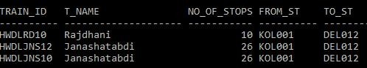

#### Arrival time of trains connect from Kolkata to Delhi:

* 1. SQL> select train_id, t_name, arr_time , from_st , to_st from train natural join route where to_st = (select station_id from station where station_name = 'Delhi') and from_st = (select station_id from station where station_name = 'Kolkata') order by arr_time asc;

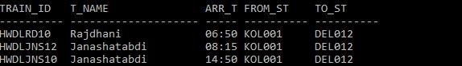

#### Details of trains leaving from Mumbai or from Chennai:

* 1. SQL> select train_id, t_name, arr_time, depart_time, from_st , to_st from train natural join route where from_st = (select station_id from station where station_name = 'Mumbai') or from_st = (select station_id from station where station_name = 'Chennai');

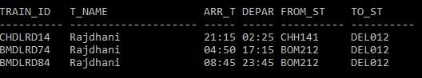

#### Trains which have less than 20 stops:

* 1. SQL> select train_id, t_name, no_of_stops , from_st , to_st from train natural join route where no_of_stops < 20;

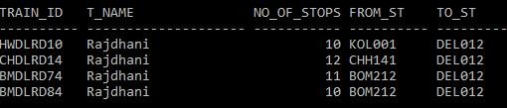

#### Passengers with ticket price more than 600 (inner join):

* 1. SQL> select passenger.pnr, p_name , train_id, ticket_id from passenger, ticket where passenger.pnr = ticket.pnr and price >600 ;

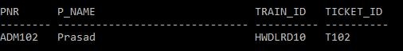

#### Cities from which Rajdhani leaves (outer join left):

* 1. SQL> select distinct station_name from train natural join route left join station on route.from_st = station.station_id where t_name = 'Rajdhani';

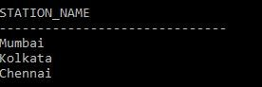

#### Trains with more than 100 on waiting seats:

* 1. SQL> select train_id, t_name, wait_seat from train natural join train_stat where wait_seat > 100;

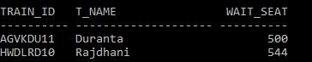

#### Trains which have available seats:

* 1. SQL> select train_id, t_name, avail_seat from train natural join train_stat where avail_seat > 0;

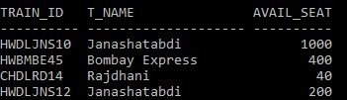

#### Total seats in each trains:

* 1. SQL> select train_id, (wait_seat+avail_seat+booked_seat) TOTAL_SEATS from train_stat;

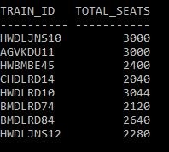

#### Average number of seats in Rajdhani:

* 1. SQL> select avg(wait_seat+avail_seat+booked_seat) AVG_seats from train_stat natural join train where t_name = 'Rajdhani';



#### Available seats on trains going from Kolkata to Delhi:

* 1. SQL> select train_id,t_name, avail_seat from route natural join train natural join train_stat where from_st = (select station_id from station where station_name = 'Kolkata') and to_st = (select station_id from station where station_name = 'Delhi');

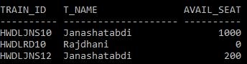

#### Ticket Id and train_id of passengers whose name starts with P:

* 1. SQL> select Train_id, Ticket_id, P_name from passenger, ticket where passenger.pnr = ticket.pnr and P_name like 'P%';

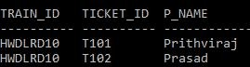

#### Departure time of trains that leave from Kolkata:

* 1. SQL> select train_id,depart_time from train natural join route where from_st = (select station_id from station where station_name = 'Kolkata');

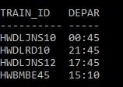

#### Arrival time of trains that reach Delhi:

* 1. SQL> select train_id,arr_time from train natural join route where to_st

= (select station_id from station where station_name = 'Delhi');

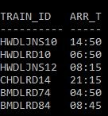

#### Departure dates and times of trains leaving for Delhi from Kolkata:

* 1. SQL> select train_id,dept_date, depart_time from train natural join route where from_st = (select station_id from station where station_name

= 'Kolkata') and to_st = (select station_id from station where station_name = 'Delhi');

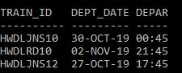

#### Arrival time of trains in Delhi order by dates:

* 1. SQL> select train_id, arr_date, arr_time from route natural join train where to_st = (select station_id from station where station_name = 'Delhi') order by arr_date,arr_time;

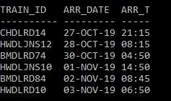

#### Time and date of the ticket booked by a particular passenger:

* 1. SQL> select ticket_id,pnr,p_name,train_id, dept_date , depart_time from (passenger natural join ticket) natural join (train natural join route) where p_name = 'Prithviraj';



#### Departure and arrival dates and times of all trains registered in the database:

* 1. SQL> select train_id,dept_date, depart_time, arr_date, arr_time from train natural join route order by dept_date;

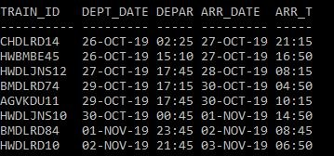

#### Generate a ticket with necessary details:

* 1. SQL> select ticket_id, pnr, p_name, age, gender, train_id, compart_no, seat_no, to_st, from_st, dept_date, depart_time, price from (passenger natural join ticket) natural join (train natural join route) where p_name = 'Prithviraj';

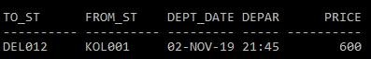

# Relational Model:

Arr_date

Dept_date

Car_no

T_name

Train_id

**Train**

|  |  |
| --- | --- |
| **User** |  |
| U-id |
|  |
| Password |
|  | |

|  |
| --- |
| **Passenger** |
| Pnr |
| P_name |
| Age |
| Gender |
| Seat_no |
| Reserve_stat |
| U_id |
| Train_id |
| Compart_no |

|  |
| --- |
| **Ticket** |
| Ticket_id |
| Pnr |
| Price |

|  |
| --- |
| **Train_stat** |
| Tstatus_id |
| Wait_seat |
| Avail_seat |
| Booked_seat |
| Train_id |

|  |
| --- |
| **Route** |
| Route_id |
| From_st |
| To_st |
| Depart_time |
| Arr_time |
| No_of_stops |
| Train_id |

|  |
| --- |
| **Station** |
| Station_id |
| Station_name |

**Future scope of the Project :**

Railway system is a huge implementation of databases and as time advances new procedures of implementing reservation of railway seats are coming up. Thus, new GUI’s are being developed making it more and more user friendly. If this database is used in making a GUI with or online application using Java Server Pages, this can be devised to be a succesful implementation.

# Conclusion:

Database Management and Data Handling is a big part of the IT industry. Thus proper knowledge of SQL is important while working on databases in order to avoid data redundancy and conflicts. Through this project, we learned to avoid such data conflicts and implement the queries properly.

# REMARKS: